**Table of Contents**

1. Purpose

1.1 Intended Audience

1.2 Intended Use

1.3 Scope

1.4 Definitions and Acronyms

1. Overall System Description

2.1 Use Case Diagrams

2.2 System Architecture

2.3 Functional Requirements

2.3.1 Startup and Main Menu

2.3.2 Reservation and Loan Management

2.4 Non-functional Requirements

2.4.1 Power Management

2.4.2 Performance

2.4.3 Security

1. Software Architecture

3.1 Static Software Architecture

1. **Purpose**

**1.1 Intended Audience**

This SRS document describes the System Requirements and Software Design for an Library Book Reservation and Collection System and the target audience are people of all ages; from kids to elder people who love reading and seek for the better experience.

**1.2 Intended Use**

The SRS defines the overall System Architecture and Requirements as well as the Software Architecture and Design. This document also contains the definition of the System Requirements which shall be used as the Input for System Test cases and Software Unit Test cases.

**1.3 Scope**

The Library Book Reservation and Collection System is designed to improve book-borrowing experience for library members. It includes the following core features:

**Book Reservation:** Users can select a branch, search for books by title or author, modify their borrowed list, and reserve books with real-time availability updates.

**Book Collection:** A countdown timer reminds users to collect reserved books, with an option to extend the collection date.

**User Accounts:** Users can register and log in to access the system.

**Book Catalog and Search:** Users can search for books by title and author.

**User Dashboard:** Users can view the number of borrowed books, payable fines for loans, and their profile information.

**Reservation Management:** Users can modify their borrowed book list before confirming reservations and extending the borrowing period.

**Accessibility:** The system is accessible via the website and follows accessibility standards.

**Security**: The system will include user data protection and secure login protocols.

**Library Integration**: It integrates with existing library management systems to synchronize book and user data.

This scope covers the essential functionalities for the initial release, with future enhancements possible based on user feedback.

**1.4 Definitions and Acronyms**

|  |  |
| --- | --- |
| Acronym | Description |
| PiCam 2 | Raspberry Pi Camera Module 2 |
| RFID | Radio-Frequency Identification |
| LED | Light Emitting Diode |
| LCD | Liquid Crystal Display |
| I2C | Inter-Integrated Circuit |
| SW | Software |
| HW | Hardware |
| GPIO | General-Purpose Input/Output |
| SPI | Serial Peripheral Interface |
| CSI | Camera Serial Interface |
| evSleep | Event to Enter Low Power Mode |
| evWakeup | Event to Enter High Power Mode |

1. **Overall System Description**

**2.1** **Use Case Diagrams**

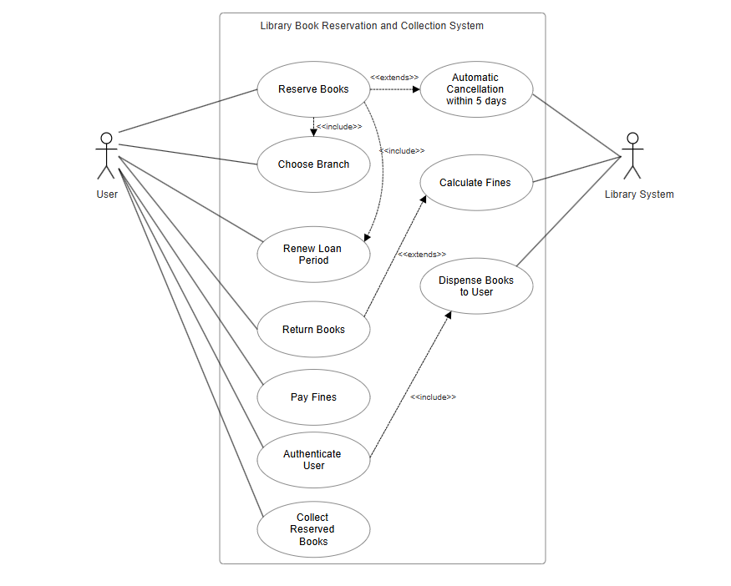

**2.2** **System Architecture**

**2.3 Functional Requirements**

2.3.1 Start-up and Main Menu

|  |  |
| --- | --- |
| REQ_ID | Requirement |
| REQ-01 | The system shall allow users to search for books online through a website.  Line 1 =”1. Enter Book Code”  Line 2 = “ **************** ” |
| REQ-02 | The system shall allow users to make reservations for the selected books via the online platform.  Line 1 = “1. Reserve Book”  Line 2 = “2. Make Payment” |
| REQ-03 | The system shall now authenticate the user.  Line 1 = “1. Type in your ID”  Line 2 = ” 123456789 “ |
| REQ-04 | The system shall enable users to specify the library branch for book collection during the reservation process.  Line 1= “1. Choose Branch”  Line 2= “2. Enter Branch Number” |

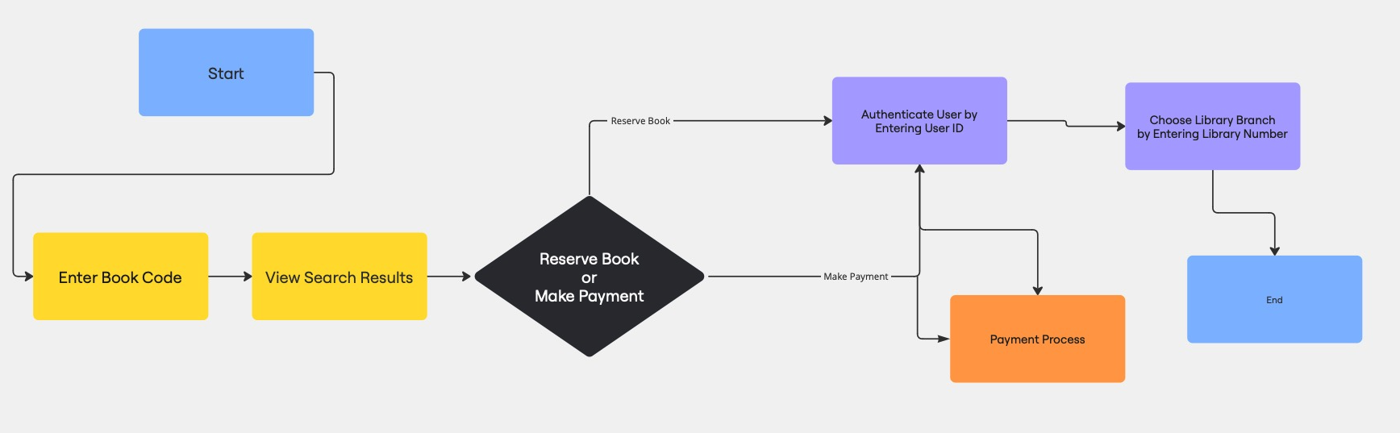

2.3.2 Reservation and Management

|  |  |
| --- | --- |
| REQ-05 | [The system shall automatically cancel reservations for books that are not collected within 5 days.  Line 1 =”Collect book within “  Line 2 =”5 days” |
| REQ-06 | The system shall set the loan period for each book to 18 days, with the option for users to renew the loan once for an additional 7 days.  Line 1 = “Loan Period:18 days” |
| REQ-07 | The system shall enforce a maximum borrowing limit of 10 books per user at any time.  If the user exceeds the maximum borrowing limit, the lcd will show:  Line 1 =” Exceeds Limit” |
| REQ-08 | The system allows users to return borrowed books by scanning the ISBN barcode at the return kiosk.  The Scanner will scan the Code and show the Book Code on the LCD screen. |
| REQ-09 | The system shall impose a fine of $0.15 per book per day for overdue returns. |
| REQ-10 | The system shall require users to pay outstanding fines at a self-service machine equipped with an RFID card reader before collecting book reservations.  When the user reserves a book, they can check the fines by going to the make payment section.  Else, after choosing a book for reservation, if there are any fines, it will show on the LCD. |
| REQ-11 | The system shall authenticate users by scanning the barcode on their NRIC or SP Student Card before dispensing reserved books.  Line 1= “Please scan your QR code”  After scanning the barcode of the user, the LCD shall display  Line 1= “Successful” |
| REQ-12 | The system shall dispense reserved books to the user only after successful authentication and validation of any outstanding fines. |

Flowchart for Reserving Book

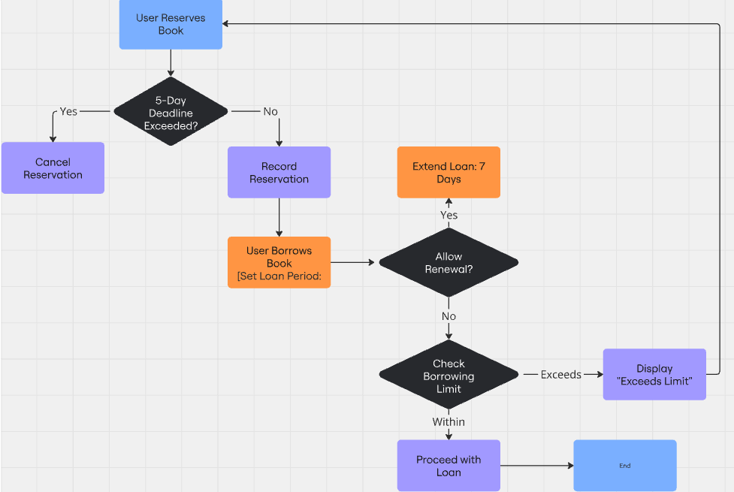

REQ 07

REQ 05

REQ 06

Flowchart for Returning Book

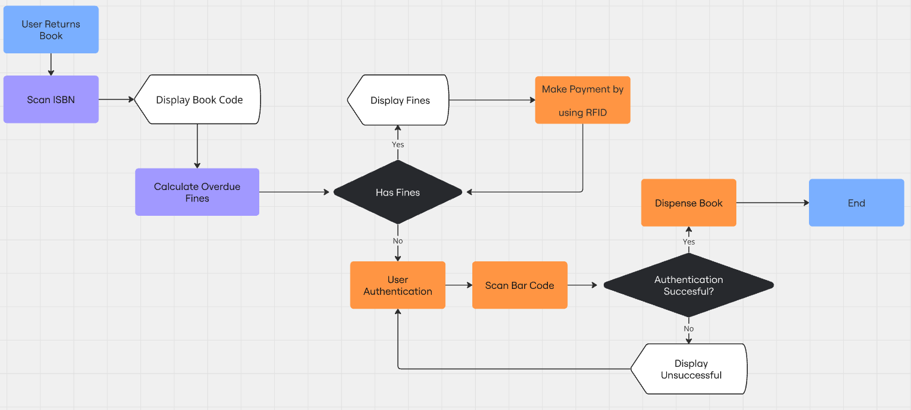

REQ 12

REQ 08

REQ 09

REQ 10

REQ 11

**2.4 Non-Functional Requirements**

2.4.1 Power Management

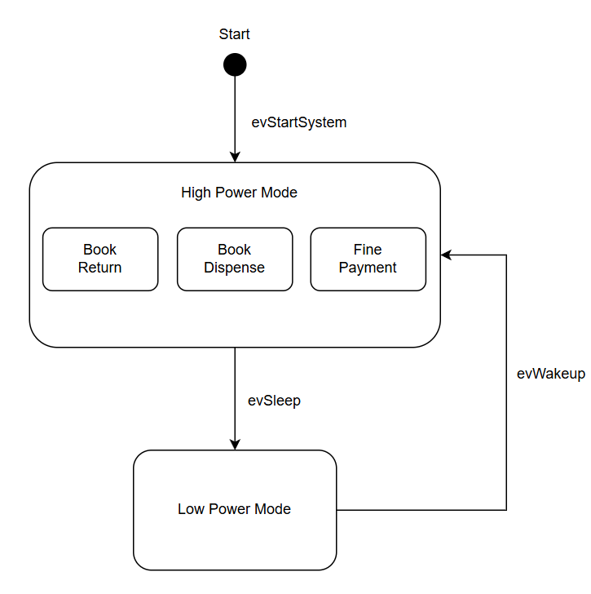

The Library Book Reservation and Collection System operates in two power modes, as shown in the State Machine diagram. Transitions between **Low Power Mode (LPM)** and **High Power Mode (HPM)** are triggered by events labeled **"evSleep"** and **"evWakeup"**. The conditions for these transitions are outlined in the system's requirements, ensuring effective power management, responsive functionality, and a seamless user experience.

|  |  |
| --- | --- |
| REQ_ID | Requirement |
| REQ-13 | Triggers evWakeup:  When the user is interacting with the system by pressing any button in the interface |
| REQ-14 | Triggers evWakeup:  When the RFID scanner detects a valid library card(e.g NRIC or student card) |
| REQ-15 | Triggers evWakeup:  When a book is scanned for return using the ISBN barcode scanner |
| REQ-16 | Triggers evSleep:  When the system detects no user interaction for a certain period |
| REQ-17 | Triggers evSleep:    When the user has completed their task such as:   * Collecting reserved books * Returning books via the barcode scanner * Clearing outstanding fines |

2.4.2 Performance

|  |  |
| --- | --- |
| REQ-18 | The website must load the searching results and reservation details within 5 seconds |

2.4.3 Security

|  |  |
| --- | --- |
| REQ-19 | The system must log out users after 10 minutes of inactivity |
| REQ-20 | Only authenticated users can access hardware components like the RFID reader or barcode scanner |

1. **Software Architecture**

**3.1 Static Software Architecture**

